**NASA EVA**

**Gamification**

**M E D I A W I K I I N S T A L L (W I N D O W S)**

**PHASE II**

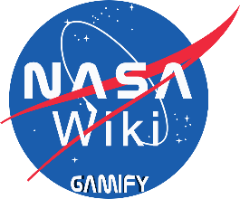

**Prepared By**

Laura Addiego

Samia Alam

Kelli Corey

Charles Milk

Adeola Odusola

Hung Pham

Table of Contents

Introduction 3

Document Overview 3

Operating System 3

Web Browser 3

Firefox 3

Chrome 3

MariaDB/MySQL 3

MariaDB 3

Installation Instructions: 4

MySQL 9

HTTP Server 9

IIS 9

IIS Express 9

Microsoft Web Platform Installer 12

PHP 14

IIS 14

IIS Express 14

MediaWiki 17

NASA EVA Gamification Extension Installation Instructions 25

Earning Points 28

By Creating a Page 28

By Editing a Page 28

Checking Your Points and Badges Earned 29

Appendix A: 7-Zip 30

Appendix B: 7. Start IIS or IIS Express 31

IIS 31

IIS Express 31

Appendix C: Papercut 32

|  |  |  |  |
| --- | --- | --- | --- |
| **Version Number** | **Description of Change** | **Author** | **Date** |
| 1.0 | Initial Creation of Document | Michael Salgo | 03/17/2018 |
| 1.1 | Additional formatting and removed CentOS placeholder steps | Michael Salgo | 04/10/2018 |
| 2.0 | Additional Formatting | Laura Addiego | 06/17/2018 |
| 2.1 | Added additional on explanation and screenshots. | Laura Addiego | 07/27/2018 |

\***Credits:** This Media-Wiki installation instructions was prepared by the following Team: Michael Salgo, Victoria Guadagno, Okechukwu Ogudebe, Jacqueline Macfadyen, Kevin Fortier, and Montrell Nuble.

The current team, worked on enhancing the graphics and numbering the instructions for better understanding.

# Introduction

## Document Overview

This document will detail the steps needed to get MediaWiki up and running on a Windows-based environment.

# Operating System

It is recommended to use Windows 7 or higher, 64-bit or 32-bit.

# Web Browser

It is recommended to install the latest version of Mozilla Firefox or Google Chrome.

## Firefox

The latest version of the Mozilla Firefox web browser can be found here: <https://www.mozilla.org/en-US/firefox/>.

## Chrome

The latest version of the Google Chrome web browser can be found here: <https://www.google.com/intl/en/chrome/>.

# MariaDB/MySQL

Either of these two databases are supported by MediaWiki. The version to install, as dictated by the Meza installer, is 5.5 for both MariaDB and MySQL.

## MariaDB

The latest version of MariaDB can be found here: <https://downloads.mariadb.org/mariadb/>.

### Installation Instructions:

1. Scroll down the page and look for “MariaDB 5.5 Series” – beneath this section there will be a “Download 5.5.[latest version number] Stable” button where [latest version number] will be the number of the latest version. At the time of this writing, the latest version is 5.5.59.
2. After clicking on the Download button, you will be brought to a download page, such as <https://downloads.mariadb.org/mariadb/5.5.59/>. Download either the 64- or 32-bit version for either the Windows x86_64 or the Windows x86 OS / CPU, respectively. Clicking on the “Windows” checkbox on the right-hand side under “Operating System” will help reduce the choices on the screen, making it easier to determine which file to download.
3. The recommended choice is to download the MSI file as it requires less bandwidth and does not have to be unzipped once downloaded.

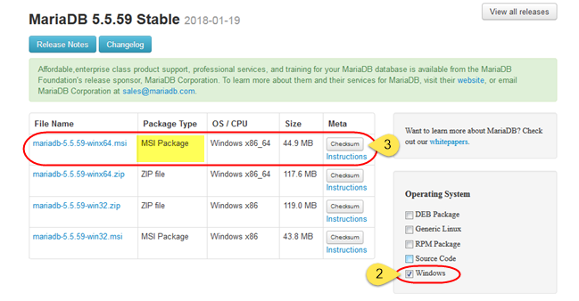

1. Once downloaded, double-click the .**msi** file to start the install.

Click “**Run**” if a security warning dialogue appears.

1. Start the install by clicking “Next.”

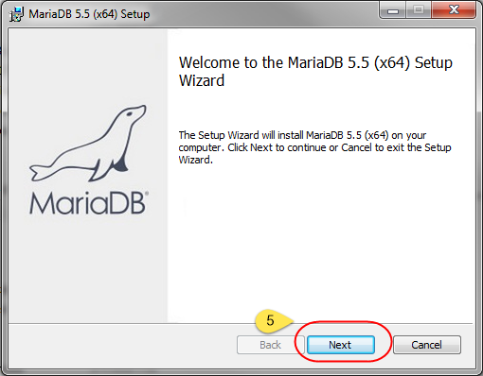

1. Click on the “I accept the terms in the License Agreement” checkbox and click on “Next.”

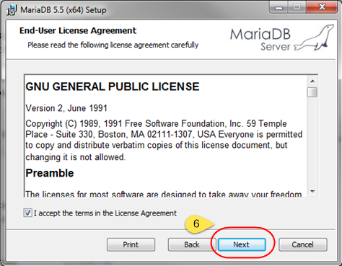

1. Leave every setting as is, unless you want to change the location of the install, and click on “Next.”

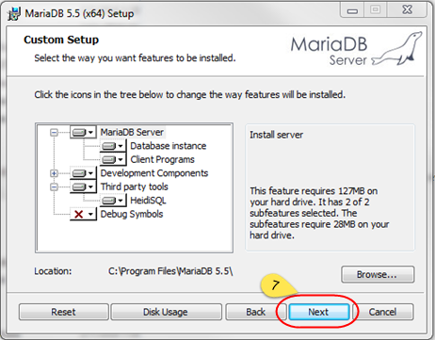

1. Type in a new root password for yourself, and
2. “Confirm:” textbox – leave all other options as is and click on “Next.”

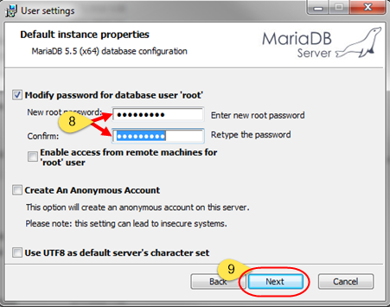

1. Leave everything as is and click on “Next.”

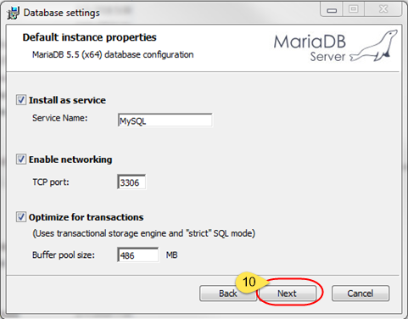

1. Leave everything as is and click on “Next.”

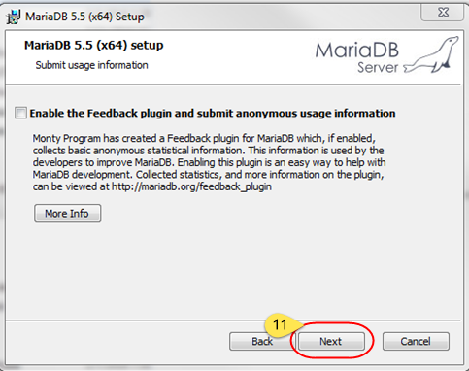

1. Click on “Install.”

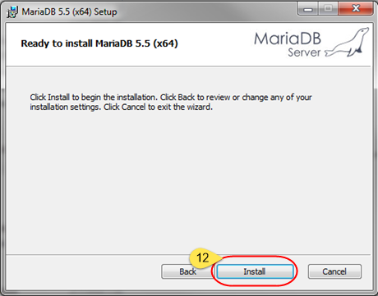

1. Click on “Finish.”

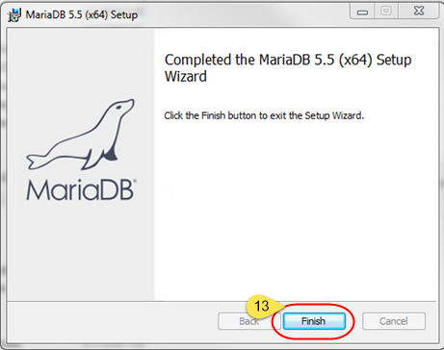

## MySQL

** Installation steps for MySQL under Windows are not presently documented **

# HTTP Server

## IIS

** Installation steps for IIS under Windows are not presently documented **

## IIS Express

The easiest way to install IIS Express will be to first install the **Microsoft Web Platform Installer** (**WPI**). Read and follow the steps to download the WPI below to be able to easily install IIS Express on your Windows computer. Come back to this section for the next steps thereafter.

1. Go to Start 🡪 All Programs and look for and click on “Microsoft Web Platform Installer.”
2. Once WPI loads, type in “IIS Express” in the search bar on the top right and press Enter on your keyboard.

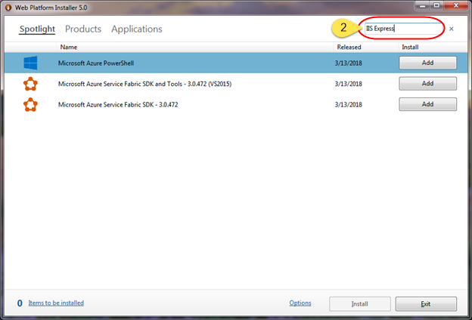

1. Click on the “Name” column header to sort the list by name.

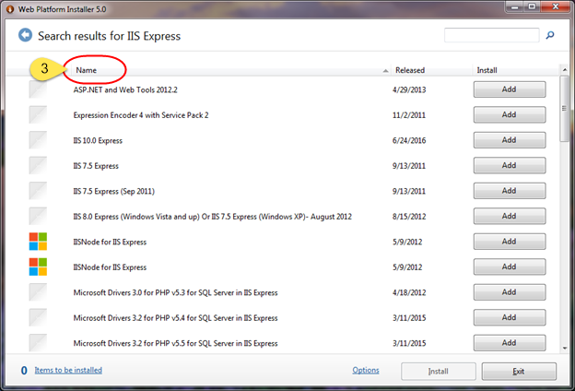

1. Click on the “Add” button next to either the IIS 10.0 Express, IIS 7.5 Express (either option) or the IIS 8.0 Express. It is recommended to use the IIS 8.0 Express version as it is more proven than the 7.5 version and more well-documented than the 10.0 version.
2. Click “Install” on the bottom right to start the IIS 8.0 Express installation.

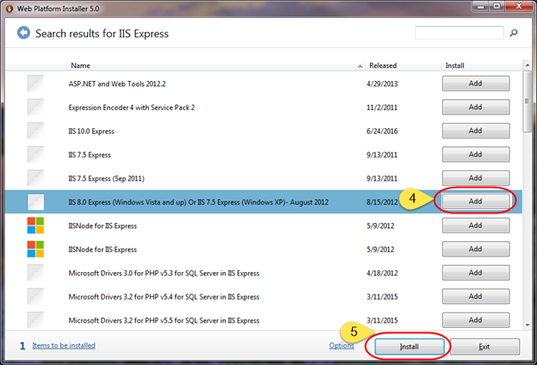

1. Click “I Accept” on the bottom right to accept the Microsoft license terms.

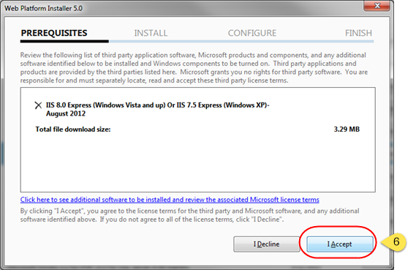

1. Click on “Finish” to complete the installation.

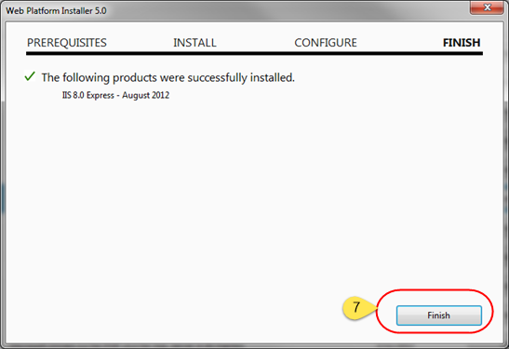

## Microsoft Web Platform Installer

At the time of this writing, the latest version is 5.0. Microsoft Web Platform Installer (WPI) can be obtained by going to <https://www.microsoft.com/web/downloads/platform.aspx>.

Once on this website:

1. Click on “Install this extension.” If a dialogue prompt appears to open or save the file, save it.

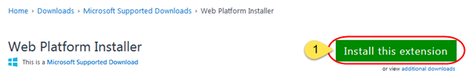

1. Once downloaded, double-click the .**msi** file to start the install. Click “Run” if a security warning dialogue appears.
2. Start the install by clicking the “I accept the terms in the License Agreement” checkbox and
3. Click on “Install.”

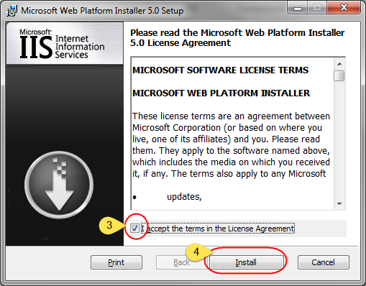

1. Click on “Finish” to complete the installation.

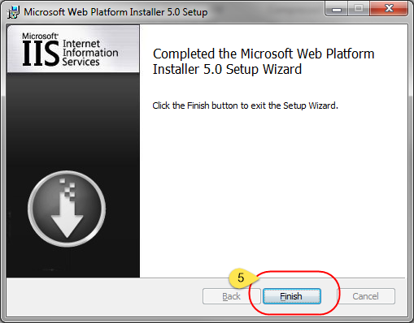

Return to the Windows-based IIS Express install instructions above.

# PHP

PHP is a platform free coding language which is the language used by MediaWiki. The Meza package installs version 5.6 of PHP.

The latest version of PHP 5.6 at the time of this writing is 5.6.31. The easiest way to install PHP on Windows is to use the Web Platform Installer (WPI).

## IIS

** Installation steps for IIS under Windows are not presently documented **

## IIS Express

Go to Start 🡪 All Programs and look for and click on “Microsoft Web Platform Installer.”

Once WPI loads,

1. Type in “PHP IIS Express” in the search bar on the top right and press Enter on your keyboard.

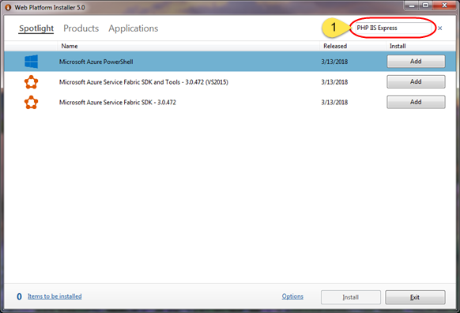

1. Click on the “Name” column header to sort the list by name.

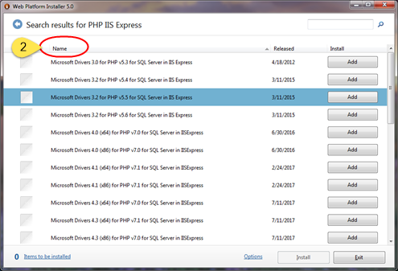

1. Scroll down and click on the “Add” button next to “PHP 5.6.[latest version number] IIS Express” where the [latest version number] will be the latest version available.
2. Click “Install” on the bottom right to start the PHP for IIS Express installation.

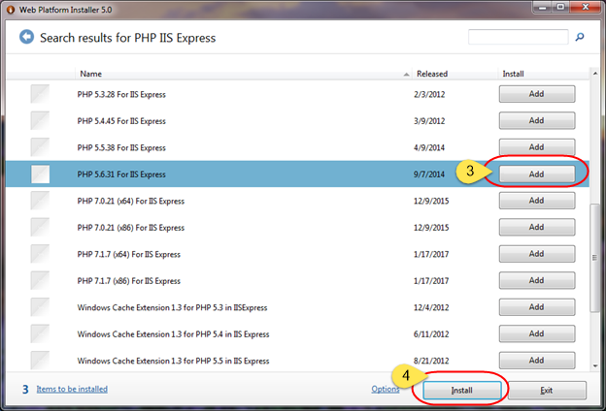

1. Click “I Accept” on the bottom right to accept the Microsoft license terms.

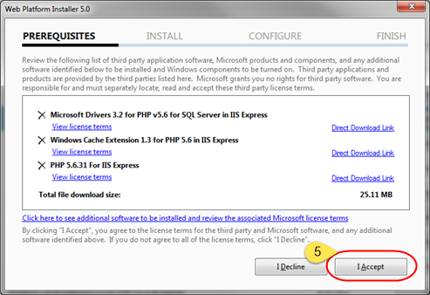

1. Click on “Finish” to complete the installation.

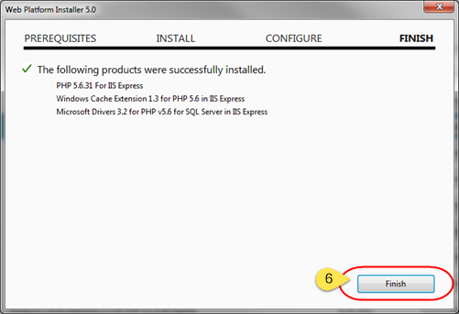

# MediaWiki

MediaWiki is an open source wiki platform which is the foundation for this project. The Meza package installs version 1.27 of MediaWiki.

The latest version of MediaWiki 1.27 can be found here: <https://www.mediawiki.org/wiki/Download>.

1. Locate the “download” link for MediaWiki 1.27.[latest version number] where [latest version number] will be the number of the latest version. At the time of this writing, the latest version is 1.27.4.

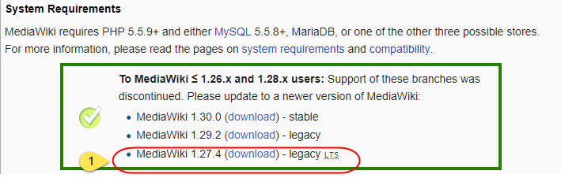

This will download a .tar.gz file which needs to be double unzipped in order to get to the files needed. Windows does not come with a way to unzip .tar.gz files so a third party program will need to be installed. Read and follow the steps to download 7-Zip, a free unzipping utility, below to be able to unzip the contents of this download file. Come back to this section for the next steps thereafter.

1. Right-click the downloaded “.tar.gz” file, hover over “7-Zip,” and click on “Extract Here.” This will create a .tar file which itself needs to be unzipped.

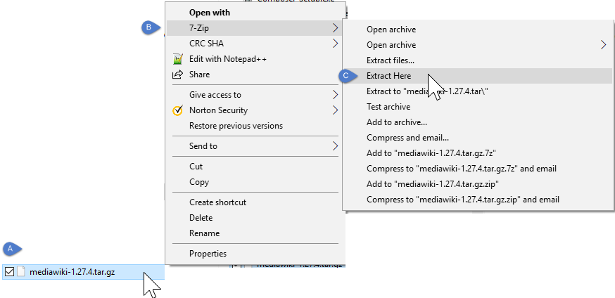

1. Right-click the unzipped .tar file, hover over “7-Zip,” and click on “Extract Here.” This will take a minute or so to unzip as there are a lot of files in this folder.

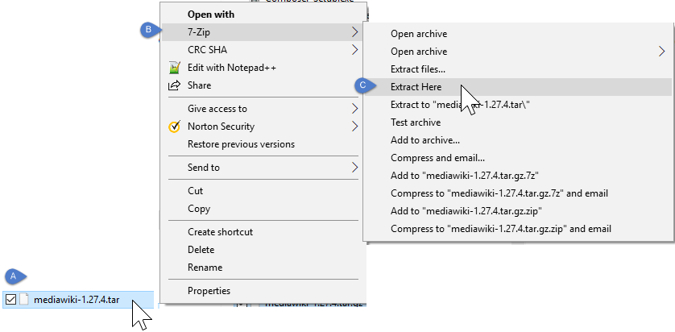

1. Place this folder (or a copy of this folder) somewhere convenient as it will be used very frequently when viewing or modifying the MediaWiki. This folder will be referred to as the **MediaWiki** folder in steps below.
2. Right click your “Command prompt” or “Windows PowerShell” and select “Run as Administrator” -not running as administrator could generate an error when running the command. Click “yes” at the prompt.

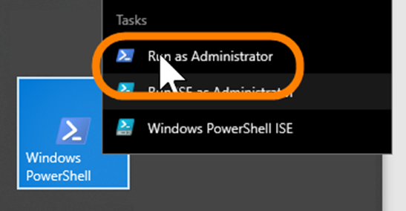

1. Change the directory to the MediaWiki folder path.

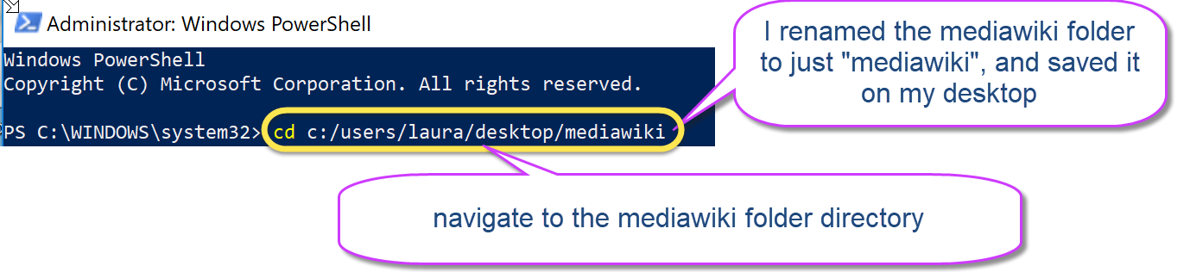

1. Start IIS or IIS Express by following the steps below (Appendix B: 7. Start IIS or IIS Express) to be able to access these files within the MediaWiki folder like a web site. Come back to this section for the next steps thereafter.
2. Open up your web browser (Chrome or Firefox) and go to <http://localhost:8080>. A default home page will appear.

Click on the “set up the wiki” link.

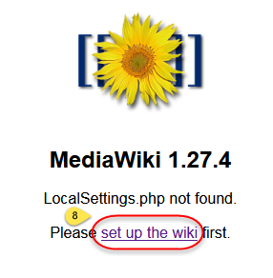

This will take you to the <http://localhost:8080/mw-config/index.php> page.

1. Click on “Continue 🡪” or change your language if desired.

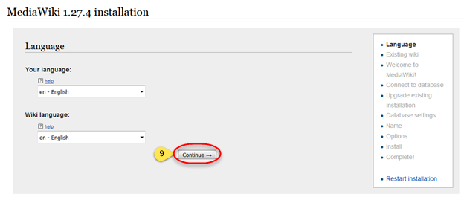

1. Scroll down to the bottom of the page and click on “Continue 🡪.”

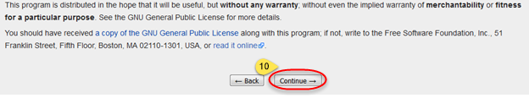

1. Leave “Database type:” as “MySQL (or compatible)” as the “or compatible” references MariaDB. Leave all other information as is,
2. Type in a “Database password:” and
3. Click on “Continue 🡪.” You can use the same password as your MariaDB install if desired.

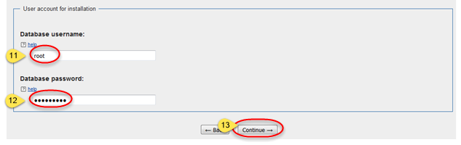

1. Leave “Storage engine:” as InnoDB and
2. change “Database character set:” to UTF-8 as these settings mimic what is installed with the Meza install.
3. Click on “Continue 🡪.”

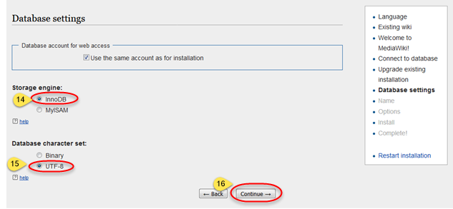

1. Give your Wiki a name such as “My Wiki,”

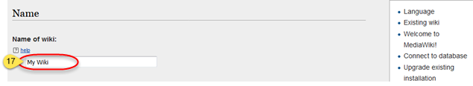

1. Type in a username and
2. Type in a password. You can use the same password as your MariaDB install if desired.
3. Confirm password.
4. Leave all other settings as is (including “Email address:”
5. Click on “Continue 🡪” at the bottom of the page.

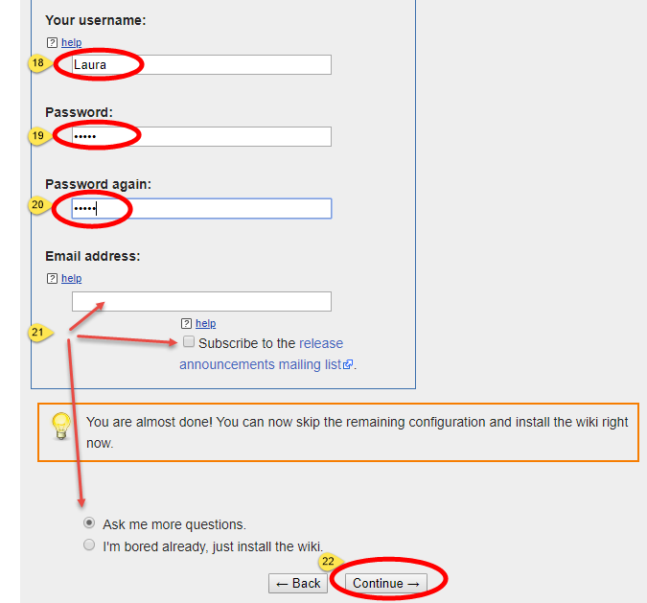

1. Leave all settings as is and scroll down to the bottom of the page and click on “Continue 🡪.” Some extensions may be enabled from here for future use, but for now at the time of this writing, no extensions are needed.

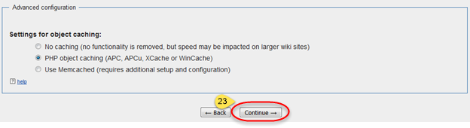

1. 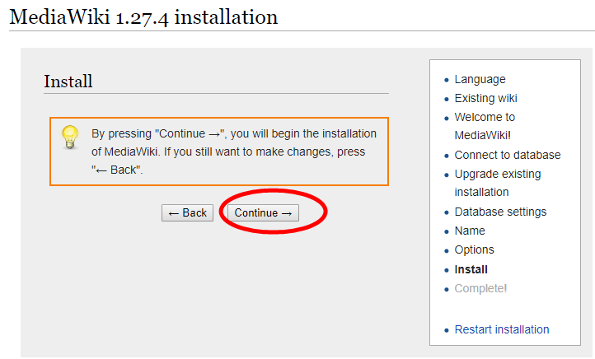Click on “Continue 🡪.”

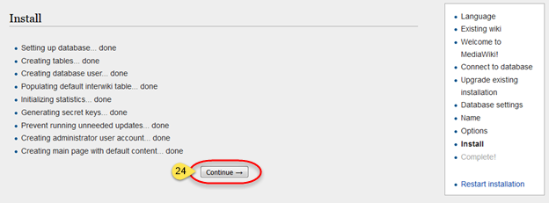

1. A dialogue will appear with an option to open or save a LocalSettings.php file. **Save this file in the MediaWiki folder** at the root level or save it somewhere else first and move it to the MediaWiki folder thereafter.
2. A confirmation message will be displayed confirming the success of the installation.

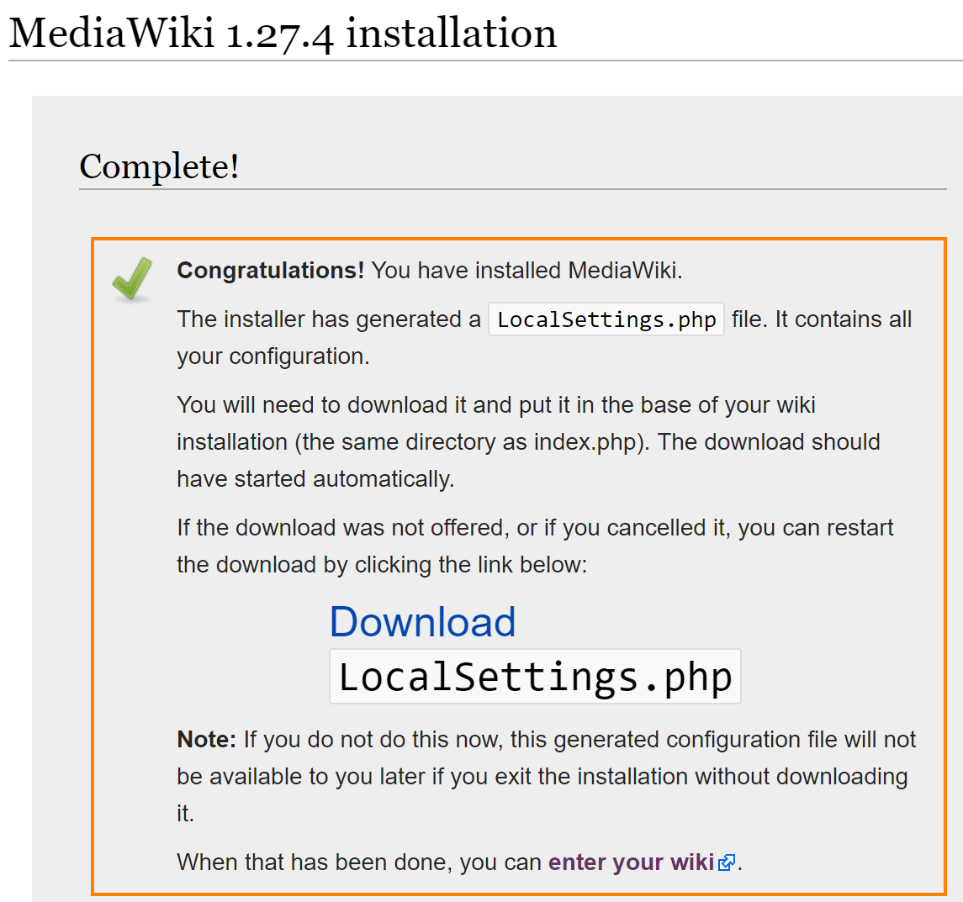

*Note: If you missed to download the “LocalSettings.php” file on the previous step, you may click on the link “Download” and save it. This will be your last chance of doing so.*

1. Access in your browser: <http://localhost:8080> and login using the username and password you created during installation to confirm that the MediaWiki installation was successful.
2. If successful, log out; if not, review the steps described above and try again.
3. Stop the IIS Express by entering ‘Q’ in the console -but don’t close it yet, as we are going to continue working on it.

# NASA EVA Gamification Extension Installation Instructions

1. Obtain the code from [GitHub](<https://github.com/SWEN670NASAEVA2/NASA_EVA_Gamification>)

2. From the extracted files and folders, copy the entire folder called `NASA_EVA_Gamification`.

On your local MediaWiki folder installation navigate to the `mediawiki/extensions/` folder and paste the ‘NASA_EVA_Gamification’ folder.

3. Located at root level of your “MediaWiki” folder edit ‘LocalSettings.php’.

1. Change the default MediaWiki logo:

Find $wgLogo and replace everything after the '=' sign with the following:

"$wgResourceBasePath/extensions/NASA_EVA_Gamification/images/nasa-wiki-logo.png";

The line should look like:

$wgLogo = "$wgResourceBasePath/extensions/NASA_EVA_Gamification/images/nasa-wiki-logo.png";

1. Add global variables

add the following code at the bottom of your `LocalSettings.php` file and save the changes:

# Nasa Eva Gamification >> Phase 1

wfLoadExtension(

'NASA_EVA_Gamification' );

$wgShowDebug = true;

$wgDebugComments = true;

$wgEnableParserCache = false;

$wgCachePages = false;

# Nasa Eva Gamification >> Phase 2

$wgPhase2Images = "$wgResourceBasePath/extensions/NASA_EVA_Gamification/images/";

$wgProfilePage=$wgServer.$wgResourceBasePath."/index.php/Special:UserGamificationProfile";

$wgBadges=array('platinum'=>'500','gold'=>'200','silver'=>'100','bronze'=>'50');

$wgPoints = array(0=>50, 1=>100);

$wgLeaderBoardPointScale=100;

1. Save the file.

***Note****: $wgShowDebug = true; is for debugging purposes; so, it is recommended to have it set to “true” in a development environment and set to “true” in a production environment.*

4. Replace the default logo with the NasaWiki gamification logo: open 'LocalSettings.php' and search for

5. If you have not stopped IIS Express yet, stop it by entering the letter ‘Q’ in the console, but don’t close it.

6. At this point, on the shell prompt, you should be on the MediaWiki folder. If you accidentally closed it, open it again as an Admin, and navigate to the folder where you have saved the "MediaWiki"

a) Run the following command:

**php maintenance/update.php**

b) Wait for a confirmation message

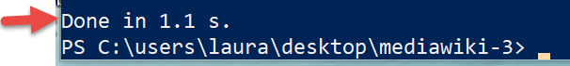

## Note: if you get a security error, run the shell prompt as an administrator.

7. Move and replace the following files “From” the specified folder “To” the specified folder.

a) File: WikiPage.php

From folder: `mediawiki/extensions/NASA_EVA_Gamification/`

To folder: `mediawiki/includes/page/`

b) File: Revision.php

From folder: `mediawiki/extensions/NASA_EVA_Gamification/`

To folder: `mediawiki/includes/`

8. From a shell prompt,

a) Navigate to the folder where you have saved the `MediaWiki`

b) Run `**runphp.cmd**`

9. Open a web browser and access your local instance: <http://localhost:8080>

1. Click “Log in” on the upper right corner link.
2. Use the username and password that you created when installing the Wikimedia or create a new user.
3. From the left hand-side navigation select `Special pages`
4. Scroll down (almost until the end of the page) and verify that under the `Other Special pages` section the "User Gamification Profile" extension has been successfully installed.
5. Click on `User Gamification Profile` to confirm that the extension was install successfully.

Please note that since you have not added or edited any page, you will see just your username and name (if you have it defined) with a message stating:  
*No data found!*

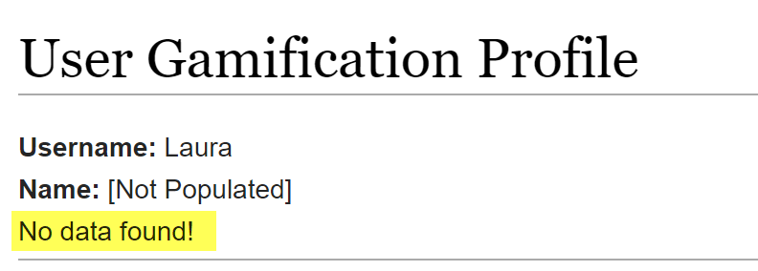

10. You are Done!!

## Note

This extension was designed for MediaWiki 1.27 or later.

# Earning Points

## By Creating a Page

1. Click on “Talk” on the upper right navigation.
2. Click on “Create”

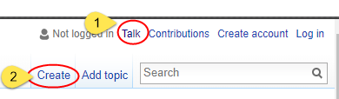

1. Type in your text, scroll down, and click on “Save page”.

## By Editing a Page

1. Click on “Main page” on the left-hand side navigation or navigate to the page you want to edit.
2. Click on “Edit”

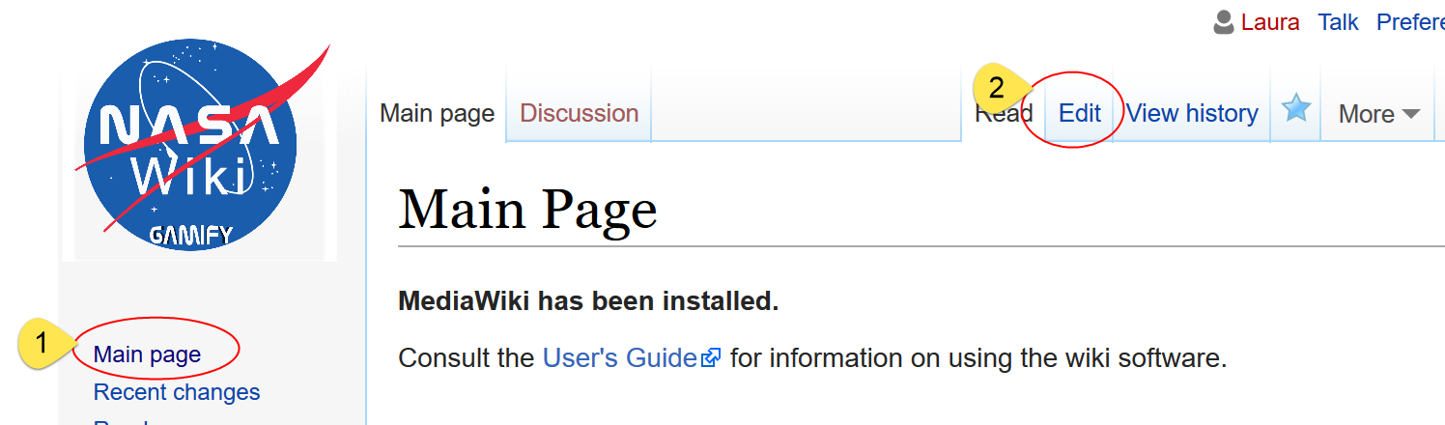

1. Edit/Add the content of the page, scroll down, and click on “Save page”.

# Checking Your Points and Badges Earned

Visit the “User Gamification Profile” to see points being added and badges being earned as you add and edit posts.

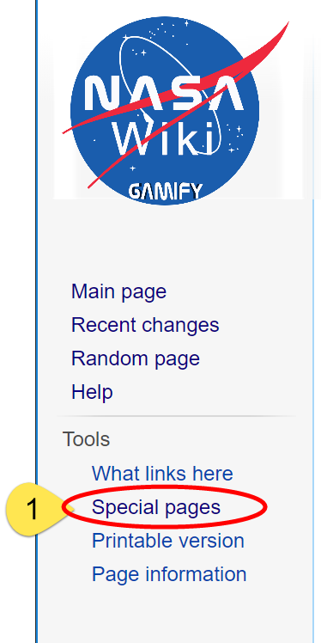

1. Click on “Special pages”
2. Scroll down
3. Under “Other special pages” click on “User Gamification Profile”
4. See the dashboard being displayed.

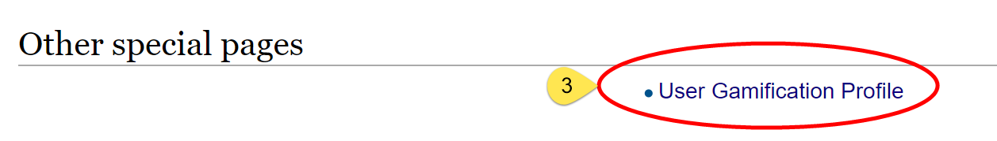

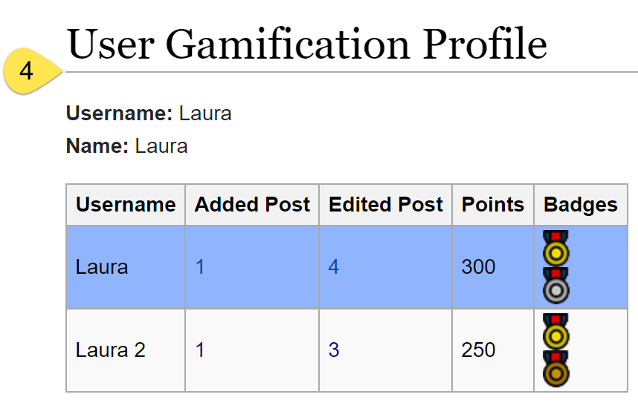

Appendix

# Appendix A: 7-Zip

The latest version of 7-Zip can be found here: <https://www.7-zip.org/>.

1. Click on “Download” for either the 64- or 32-bit Windows version as needed.

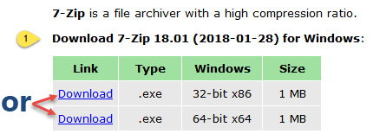

1. Once downloaded, double-click the.exe file to start the install.
2. Click “Run” if a security warning dialogue appears.
3. Click “Install” or change your folder destination first if required.

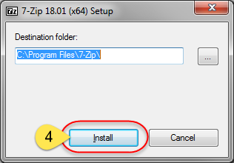

1. Click “Close.”

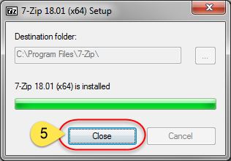

Return to the Windows-based MediaWiki install instructions above.

# Appendix B: 7. Start IIS or IIS Express

## IIS

** Installation steps for IIS under Windows are not presently documented **

## IIS Express

Type in “runphp.cmd” and hit enter on your keyboard. This will start IIS Express which will allow for the contents of the MediaWiki folder to act as a web site under <http://localhost:8080/>.

Return to the Windows-based MediaWiki install instructions above.

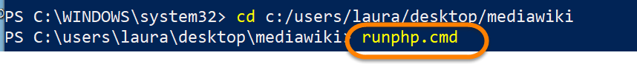

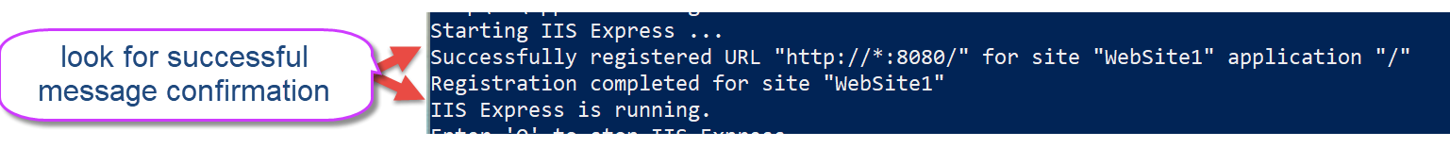

\**Note*: before running “runphp.cmd” make sure you are in the correct path -you have navigated to the MediaWiki folder.

# Appendix C: Papercut

The latest version of Papercut can be found here: <https://github.com/ChangemakerStudios/Papercut/releases>.

1. Click on “Papercut.Setup.exe” to download this program. The latest version of this software at the time of writing is 5.1.23.

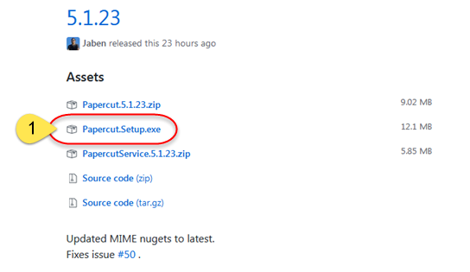

1. Once downloaded, double-click the Papercut.Setup.exe file to start the install.
2. Click “Run” if a security warning dialogue appears.
3. Click on “Install” or click on “Options” first to change the installation path if desired.

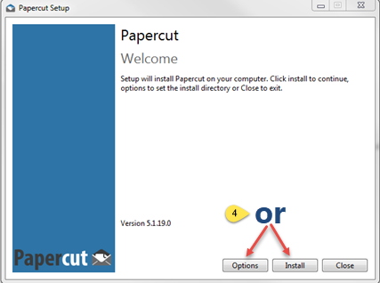

1. A pop-up dialogue will appear, click on “Next.”

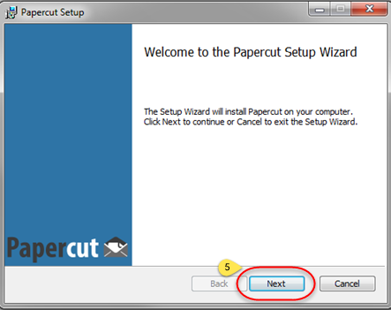

1. Leave everything as is and click on “Next.”

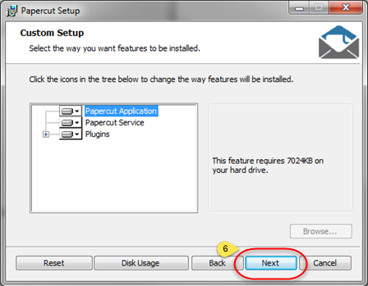

1. Click on “Install.”

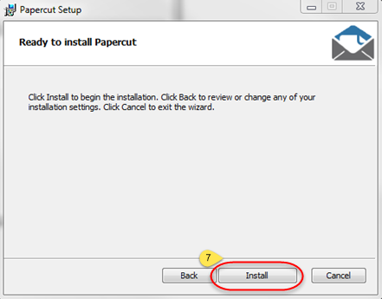

1. Click on “Finish.”

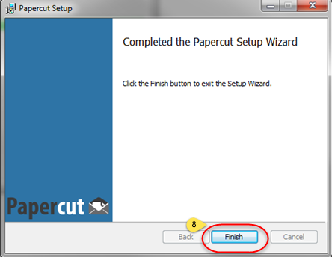

1. Click on “Close.”

